

***Applicant Pack for the post of Class Teacher***

***June 2023***

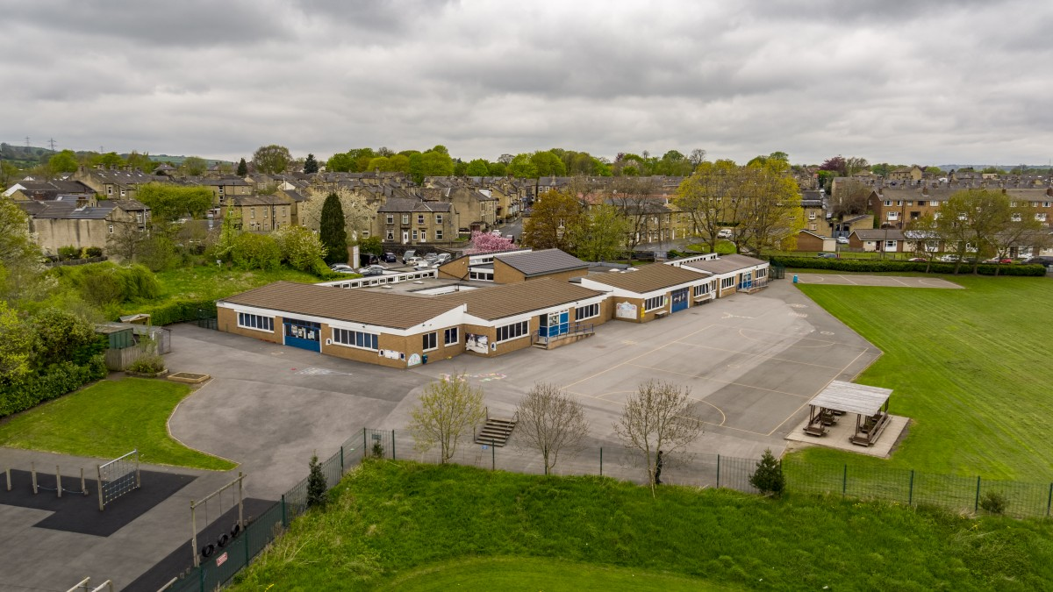

**St Andrew’s CE (VA) Junior School**

**Waterloo Road, Brighouse**

**Huddersfield HD6 2AN**

**Telephone number: 01484 712895**

**Website:** [**www.standrews.calderdale.sch.uk**](http://www.standrews.calderdale.sch.uk)

***‘Promoting excellence within a caring Christian community’***

# St Andrew’s C.E. (VA) Infant & Junior Schools

Waterloo Road, Brighouse HD6 2AN

**Class Teacher – Key Stage 2**

**Will suit main pay scale**

**About the role**

The Federated Governing Board of St Andrew’s CE (VA) Infant and Junior Schools is looking to appoint an enthusiastic, hard-working teacher to teach one of our Key Stage 2 classes at our Junior School. The role will start from September 2023 or as soon as possible thereafter.

**About you**

We welcome candidates who are:

* Excellent classroom practitioners
* Committed to inclusive learning
* Keen to contribute to a very supportive team
* Able to support the Christian ethos of our school.

Applicants should have excellent all round curriculum and classroom skills. Applications from ECTs will be considered.

**About Us**

St. Andrew’s CE Junior School is a happy two-form entry school that welcomes children from all backgrounds. Our school has been rated ‘Outstanding’ in our most recent Ofsted (December 2022) and ‘Good’ in our SIAMS (February 2017) inspection. We have 240 pupils on roll, an incredible team of staff and supportive governors who work well together to make our school a warm and welcoming place to be. We take great pride in providing an excellent all round education for all of our pupils.

We can offer you:

* A well-resourced, attractive and spacious working environment
* Happy children who are enthusiastic about their learning
* Support and networking opportunities across the two schools in our Federation
* Robust continued professional development – we have a proven track-record of supporting and developing our staff.

Visits to the school are strongly encouraged, please telephone the school office to make an appointment.

*The school is committed to safeguarding the rights, welfare and safety of all children. The successful applicant will be subject to an enhanced Criminal Record Check (Disclosure) from the Disclosure and Barring Service before the appointment is confirmed.*

**Further details and application forms can be obtained from the school website.**

**Completed application forms should be returned to the school office or by email to:** [**SBM@standrews.calderdale.sch.uk**](mailto:SBM@standrews.calderdale.sch.uk) **by noon on Monday 19 June 2023.**

**We anticipate that interviews / lesson observations will be 28 June 2023.**

***Welcome letter from the Executive Headteacher***

Dear Applicant

I am delighted that you have expressed an interest in our vacancy for a Class Teacher.

We are a happy, thriving school and the appointment of an experienced teacher is important to the school. We were judged ‘Outstanding’ by Ofsted in December 2022. In February 2017 we were judged as ‘good’ in all areas during our SIAMS Inspection.

At the centre of everything we do is the partnership between parents/carers, staff and pupils, each taking their responsibilities seriously and having high expectations of one another.

We are fortunate to have a vibrant and spacious learning environment for our children. We are able to offer a wealth of resources which includes extensive outdoor space, a dedicated ICT suite and a spacious library.

For staff we provide on-site parking, subsidised meals, free tea and coffee and a supportive, caring community in which to work. Ours is a hard-working and happy team where all staff feel valued and supported.

I hope that you find the material in this pack useful and informative. If you wish to find out more about the role, or to visit our school, please contact the office on 01484 712895 or browse our website: [www.standrews.calderdale.sch.uk](http://www.standrews.calderdale.sch.uk)

I look forward to hearing from you.

Yours faithfully,



**Karen Smith**

Executive Headteacher



**Safer recruitment**

Safer recruitment practice aims to minimise the risk of appointing an individual who is unsuitable to work in a post where they will be in contact with children or vulnerable adults and could cause them harm.

Our selection processes observe best practice in selecting the appropriate candidate by ensuring equality of opportunity for all applicants whilst excluding any who may be unsuitable to work with our children.

The Disclosure and Barring Service (DBS) helps employers to make safer recruitment decisions and to prevent unsuitable people from working with vulnerable groups, including children.

It is a criminal offence to offer to a barred individual (or indeed for a barred individual to apply for, or to accept an offer of) employment in certain designated posts (those which involve working with children in what is defined as regulated activity).

All candidates are expected to understand their own responsibilities and duties in regard to child protection and safeguarding with due relevance to the specific post advertised.

Any conditional offer of appointment will be made strictly subject to receipt of all required documentation (as specified) and satisfactory verification of all necessary checks.





**St Andrew’s CE (VA) Junior School - about us**

St Andrew’s is a popular two-form entry junior school with 240 pupils on roll. Our school is a Church of England Voluntary Aided School and we actively foster a Christian environment. Our strong links with St. Martin’s Church mean that the clergy lead worship regularly in school and we hold services in the church.

We aim to provide our children with a broad and balanced curriculum to allow them to thrive and we provide them with many memorable experiences beyond the classroom to support this.

We work closely with our neighbouring Infant school to ensure a smooth transition to the Junior School.

Nurturing the emotional health and wellbeing of our children and staff is at the heart of everything we do. We have two learning mentors who work alongside the staff to ensure the safety and wellbeing of all our pupils.



**Ofsted 2022**

*‘Leaders prioritise staff well-being and have taken active steps to reduce workload. They provide high levels of guidance and support to teachers in the early stages of their career. There is a very special team ethos. Everyone pulls together to achieve the best outcomes for pupils.’*

**SIAMs Report 2017**

‘*Leaders share a vision for the school based on Christian values. The school is well led by the headteacher and there is overall confidence in the leadership team and the direction in which it is taking the school. Staff feel enabled and well supported’*

***Job description***

Post: KS2 Class Teacher

Line manager/s: Executive Headteacher, Head of School, SLT and the Governing Body

Salary and grade: MPS in line with the current *School Teachers’ Pay and Conditions Document*

Supervisory responsibilities:The postholder may be responsible for the deployment and supervision of the work of teaching assistants relevant to their responsibilities

|  |  |
| --- | --- |
| **Purpose** |  |
| * Be responsible for the learning and achievement of all pupils in the class/es ensuring equality of opportunity for all * Be responsible and accountable for achieving the highest possible standards in work and conduct * Treat pupils with dignity, building relationships rooted in mutual respect, and at all times observing proper boundaries appropriate to a teacher’s professional position * Work proactively and effectively in collaboration and partnership with learners, parents/carers, governors, other staff and external agencies in the best interests of pupils * Act within, the statutory frameworks, which set out their professional duties and responsibilities and in line with the duties outlined in the current *School Teachers Pay and Conditions Document and Teacher Standards (2012)* * Take responsibility for promoting and safeguarding the welfare of children and young people within the school   **Duties and responsibilities**  All teachers are required to carry out the duties of a schoolteacher as set out in the current [*School Teachers Pay and Conditions* *Document*](https://www.education.gov.uk/publications/)*.* Teachers should also have due regard to the Teacher Standards (2012). Teachers’ performance will be assessed against the teacher [standards](https://www.education.gov.uk/publications/standard/publicationDetail/Page1/DFE-00066-2011) as part of the appraisal process as relevant to their role in the school. |  |
| **Teaching** |  |

* Deliver the curriculum as relevant to the age and ability group/subject/s that you teach
* Be responsible for the preparation and development of teaching materials, teaching programmes and pastoral arrangements as appropriate
* Be accountable for the attainment, progress and outcomes of pupils’ you teach
* Be aware of pupils’ capabilities, their prior knowledge and plan teaching and differentiate appropriately to build on these demonstrating knowledge and understanding of how pupils learn
* Have a clear understanding of the needs of all pupils, including those with special educational needs; gifted and talented; EAL; disabilities; and be able to use and evaluate distinctive teaching approaches to engage and support them
* Demonstrate an understanding of and take responsibility for promoting high standards of literacy including the correct use of spoken English (whatever your specialist subject)
* If teaching early reading, demonstrate a clear understanding of appropriate teaching strategies e.g. systematic synthetic phonics
* Use an appropriate range of observation, assessment, monitoring and recording strategies as a basis for setting challenging learning objectives for pupils of all backgrounds, abilities and dispositions, monitoring learners’ progress and levels of attainment
* Make accurate and productive use of assessment to secure pupils’ progress
* Give pupils regular feedback, both orally and through accurate marking, and encourage pupils to respond to the feedback, reflect on progress, their emerging needs and to take a responsible and conscientious attitude to their own work and study
* Use relevant data to monitor progress, set targets, and plan subsequent lessons
* Set homework and plan other out-of-class activities to consolidate and extend the knowledge and understanding pupils have acquired as appropriate
* Participate in arrangements for examinations and assessments within the remit of the *School Teachers’ Pay and Conditions* *Document*

**Behaviour and Safety**

* Establish a safe, purposeful and stimulating environment for pupils, rooted in mutual respect and establish a framework for discipline with a range of strategies, using praise, sanctions and rewards consistently and fairly
* Manage classes effectively, using approaches which are appropriate to pupils’ needs in order to inspire, motivate and challenge pupils
* Maintain good relationships with pupils, exercise appropriate authority, and act decisively when necessary
* Be a positive role model and demonstrate consistently the positive attitudes, values and behaviour, which are expected of pupils
* Have high expectations of behaviour, promoting self-control and independence of all learners
* Carry out playground and other duties as directed and within the remit of the current *School Teachers’ Pay and Conditions* *Document*
* Be responsible for promoting and safeguarding the welfare of children and young people within the school, raising any concerns following school protocol/procedures

**Team working and collaboration**

* Participate in any relevant meetings/professional development opportunities at the school, which relate to the learners, curriculum or organisation of the school including pastoral arrangements and assemblies
* Work as a team member and identify opportunities for working with colleagues and sharing the development of effective practice with them
* Contribute to the selection and professional development of other teachers and support staff including the induction and assessment of new teachers, teachers serving induction periods and where appropriate threshold assessments
* Ensure that colleagues working with you are appropriately involved in supporting learning and understand the roles they are expected to fulfil
* Take part as required in the review, development and management of the activities relating to the curriculum, organisation and pastoral functions of the school
* Cover for absent colleagues within the remit of the current *School Teachers’ Pay and Conditions* document

**Fulfil wider professional responsibilities**

* Work collaboratively with others to develop effective professional relationships
* Deploy support staff effectively as appropriate
* Communicate effectively with parents/carers with regard to pupils’ achievements and well-being using school systems/processes as appropriate
* Communicate and co-operate with relevant external bodies
* Make a positive contribution to the wider life and ethos of the school
* Lead on a curriculum area. Keep abreast of curriculum developments in your subject area, ensuring you disseminate best practice across the school. Maintain existing resources and explore opportunities to develop or incorporate new resources from a wide range of sources inside and outside the school

**Administration**

* Register the attendance of and supervise learners, before, during or after school sessions as appropriate
* Participate in and carry out any administrative and organisational tasks within the remit of the current *School Teachers’ Pay and Conditions* *Document*

**Professional development**

* Regularly review the effectiveness of your teaching and assessment procedures and its impact on pupils’ progress, attainment and well-being, refining your approaches where necessary responding to advice and feedback from colleagues
* Be responsible for improving your teaching through participating fully in training and development opportunities identified by the school or as developed as an outcome of your appraisal
* Proactively participate with arrangements made in accordance with the Appraisal Regulations 2012

**Other**

* To have professional regard for the ethos, policies and practices of the school, and maintain high standards in your own attendance and punctuality
* Perform any reasonable duties as requested by the headteacher and Senior leadership Team (SLT)

**Conditions of Service**

Governed by the National Agreement on Teachers Pay and Conditions

***Person Specification***

| **Criteria** | **Essential**  **(E)**  **Desirable**  **(D)** | **Method of Assessment**  Application (A)  Interview (I)  References (R)  Observation (O) |
| --- | --- | --- |
| **Qualifications** | | |
| Qualified Teacher Status | E | A |
| Degree or equivalent | E | A |
| Evidence of recent and relevant CPD | E | A |
| **Experience** | | |
| Experience of delivering consistently good/outstanding teaching | E | A, I, R,O |
| Experience of teaching in KS2 | E | A,I,R |
| Experience of working effectively with children with a range of additional needs | E | A, I,O |
| Experience of using ICT effectively across the curriculum | E | A, I |
| Experience of successfully implementing the curriculum | E | A, I,O |
| Experience of developing a creative, enriching curriculum with quality opportunities for developing literacy and numeracy skills | E | A, I,O |
| Experience of accurately assessing pupil progress and using assessment data to inform future learning opportunities | E | A,I |
| Successful experience of leading a curriculum area | D | A,I |
| Recent experience of teaching in Lower Key Stage 2 | D | A,I |
| **Abilities, Skills and Knowledge** | | |
| The ability to maintain a well organised and vibrant learning environment which supports learning | E | A,I,O |
| Ability to work consistently, prioritise and delegate appropriately, to handle pressure and work to deadlines | E | A, I |
| Ability to communicate clearly and sensitively, both orally and in writing, with pupils, parents/carers, staff, governors, LA and the wider community | E | A, I |
| A knowledge and practical experience of strategies, policies and practice that promote equality of opportunity | D | A, I |
| Awareness and commitment to safeguarding and promoting the welfare of children and expecting all staff to share this commitment | E | A, I |
| **Teaching and Learning** | | |
| An understanding of the characteristics of an effective learning environment and the key elements of successful behaviour management | E | A,I,O |
| A secure understanding of a range of assessment strategies | D | A,I |
| Knowledge and experience of ensuring that all pupils make progress during a lesson, across a unit of work, over a half term and throughout the year | E | A,I,O |
| **Additional Factors** | | |
| Willing to contribute fully to the life of the school | E | A,I |
| Willingness to promote further links with the local and wider community | E | A,I |
| Readiness to accept and implement change, openness and willingness to learn and flexibility | E | A,I |
| Has the ability to work flexibly within a team with a positive attitude | E | A,I |
| Be a team player who is able to inspire and motivate colleagues by the quality of their work | E | A,I |
| A sense of humour | E | A,I |
| A commitment to the vision and ethos of a Church of England School | E | A,I |

(E) – essential criteria (candidates must demonstrate that they have the ability to fulfil these aspects of the job description on day 1 of the post and without any additional training

(D) – desirable criteria (the candidate must demonstrate the ability to be able to fulfil the desirable criteria of the post, with training and support)

All candidates will be short listed against the essential criteria. Only those candidates whose written application fulfils the requirements of the essential criteria will be shortlisted for interview. If a large number of candidates meet all the essential criteria, the panel will then consider the desirable criteria within the job specification.

***Our School Aims***

The intended outcome of our education at school is that students:

* Develop lively, enquiring minds, the ability to question and argue rationally and to apply themselves to tasks and physical skills, both on their own and in groups
* Acquire knowledge and skills relevant to adult life and employment and the ability to enjoy leisure in a fast changing world
* Have a respect for religious and moral values and develop non-discriminatory attitudes and practice which will enable them to live in harmony with all members of society
* Understand, care for and respect the world in which they live and the independence of individuals, families, groups, and nations
* Appreciate human achievements and aspirations
* Are helped to develop moral values and an appreciation of the spiritual dimensions of human experience
* Are helped to develop their imagination, sensitivity and creative responses to a wide range of aesthetic experiences
* Develop a sense of self-respect, self-discipline, the capacity to enjoy life as independent, self-motivated adults and the willingness to care for others



**Timeline**

**Closing date**

Completed applications should be returned no later than:

**Monday 19 June 2023 (12 noon)**

Lesson observations and interviews to be held **28 June 2023**

**How to apply**

Please complete the application form provided. The supporting statement in your application should be no longer than 2 sides of A4 with a minimum font of Arial 11. It should address the precise selection criteria detailed in the person specification and should reinforce this by giving examples to support your candidacy.

Please note that covering letters and other extraneous material will not be accepted as part of the application.

Please return your application to the school office or by email to: [sbm@standrews.calderdale.sch.uk](mailto:sbm@standrews.calderdale.sch.uk)

