Literacy Book Overview
Year 3
Autumn Term |  | Spring Term |  | Summer Term
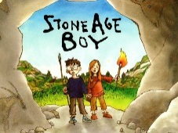  Stone Age Boy by Satoshi Kitamura  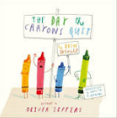  The Day the Crayons Quit by Oliver Jeffers | 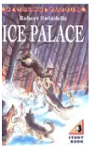  Ice Palace  Robert Swindells  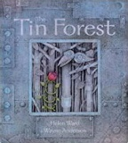  Tin Forest  Helen Ward | Alice in Wonderland  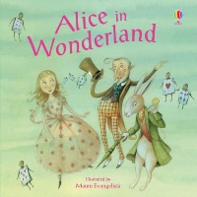 | 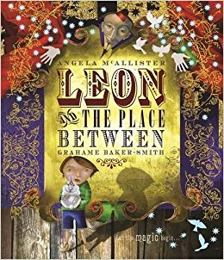  Leon and The Place Between by Grahame Barker Smith  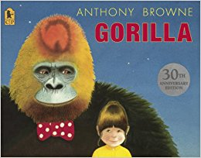  Gorilla by Anthony Browne | 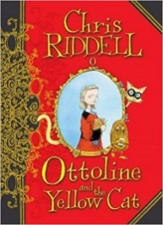  Ottoline and the Yellow Cat by Chris Riddle | 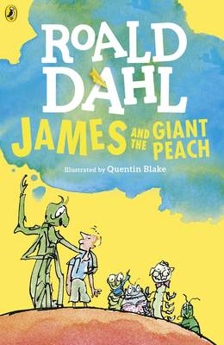  James and the Giant Peach by Roald Dahl
Year 4
Autumn Term |  | Spring Term |  | Summer Term
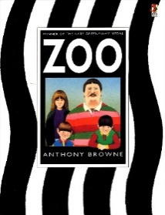  Zoo by Anthony Browne  Hansel and Gretel by Neil Gaiman  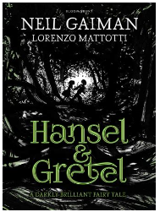 | 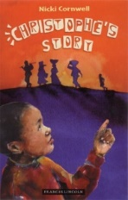  Christophe’s Story by Nicki Cornwell  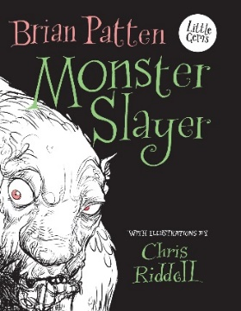  Monster Slayer by Brian Patten | 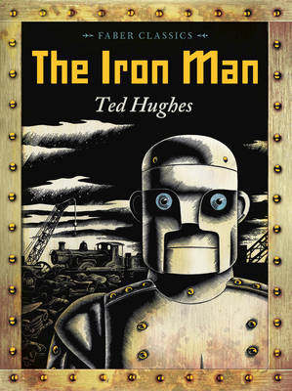  The Iron Man by Ted Hughes  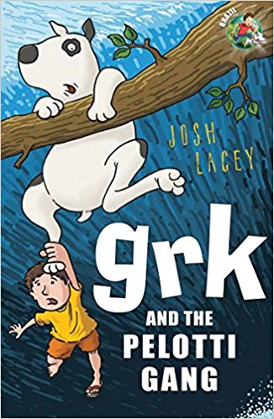  Grk and the Pelotti Gang by Josh Lacey | 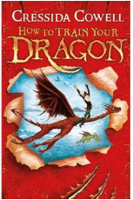  How to Train Your Dragon by Cressida Cowell | 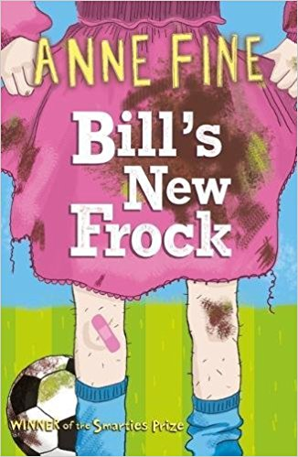  Bill’s New Frock by Anne Fine  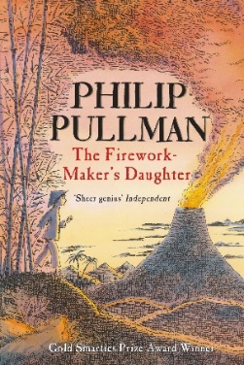  The Firework Maker’s Daughter by Philip Pullman | 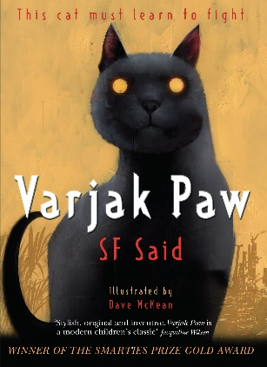  Varjak Paw by SF Said
Year 5
Autumn Term |  | Spring Term |  | Summer Term
The Day of Ahmed’s Secret by Florence Parry Heide and Judith Heide Gilliland  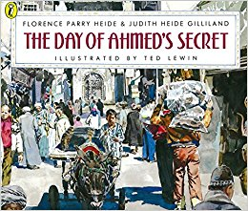  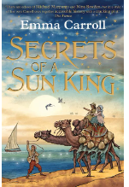  Secrets of a Sun King by Emma Carroll | Kaspar Prince of Cats by Michael Morpurgo  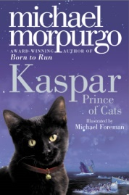 | Sir Gawain and the Loathly Lady by Selina Hastings  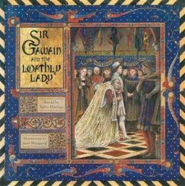  The Highwayman Narrative Poem by Alfred Noyes  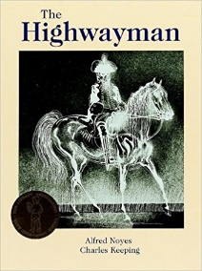 | Journey to Jo’burg by Beverley Naidoo  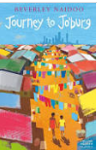 | Holes by Louis Sachar  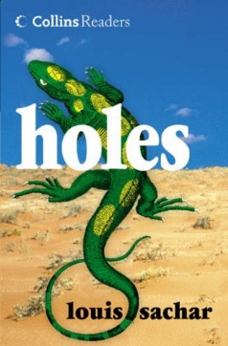 | Clockwork by Philip Pullman  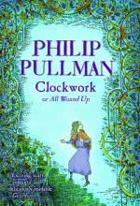

Year 6
Autumn Term |  | Spring Term |  | Summer Term
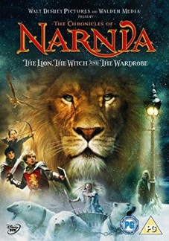  The Lion, The Witch and The Wardrobe – C.S. Lewis | 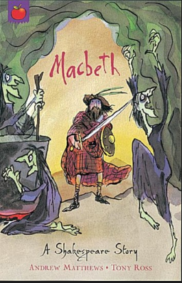  Macbeth – A Shakespeare Story by Andrew Matthews  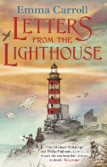  Letters from the Lighthouse by Emma Carroll. | 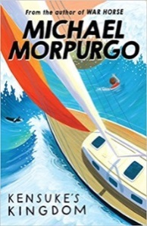  Kensuke’s Kingdom – Michael Morpurgo  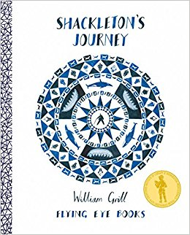  Shackleton’s Journey – William Gil | 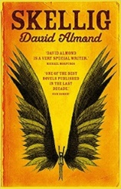  Skellig – David Almond and William Blake poetry  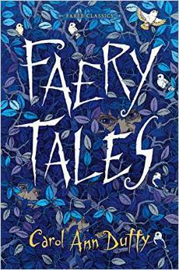  Faery Tales by Carol-Ann Duffy | 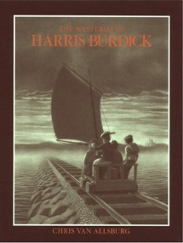  The Tales of Harris Burdick – Chris Van Allsberg  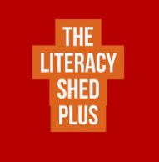  Literacy Shed suspense stories | 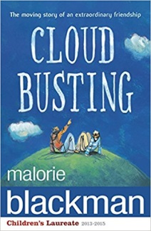  Cloud Busting – Malorie Blackman

