Literacy at St. Andrew’s Junior School
English at St Andrew’s

Contents
Page
2-11 | English policy
12 - 16 | English at St Andrew’s: Intent, implementation and impact
17 | What greater depth looks like
18 | One page plan
19 | Resources and passwords
20-22 | Book unit overview

English Policy

1 Introduction

At St. Andrew’s, we recognise that without effective communication, little achievement can be made. English is a fundamental part of learning and is taught both discreetly and across the curriculum. It is part of the ‘essential knowledge’ that is needed in society (National Curriculum, p. 6):

‘Teachers should develop pupil’s spoken language, reading, writing and vocabulary as integral aspects of the teaching of every subject. English is both a subject in its own right and the medium for teaching; for pupils, understanding the language provides access to the whole curriculum. Fluency in the English language is an essential foundation for success in all subjects.’ (National Curriculum, p. 10)

As key life skills, literacy and communication need to be taught and developed throughout a child’s life. We aim to create a shared love and understanding of literacy, enable pupils to express themselves creatively and imaginatively and give children the skills to be effective written and oral communicators.

To enable us to address these aims and ensure full coverage of the 2014 National Curriculum, we use a ‘whole book’ approach to teaching. Pupils study a class book, which is usually more challenging than one they might be able to read independently. They will use this book as the basis for reading, writing, speaking and listening tasks. Those pupils who struggle to gain age related skills will also participate in supportive sessions outside class English lessons, including same day catch up and Read Write Inc phonics interventions.

2 Rationale

We aim to develop enthusiasm for literacy in all its forms and give children the confidence to express themselves both orally and through the written word. By developing a comprehensive range of reading skills, we strive to foster in the children a love and appreciation of a variety of literature. These skills will enable them to access all aspects of the curriculum, in primary education and beyond. We agree with the authors of the National Curriculum that those children who fail to achieve in these areas are effectively ‘disenfranchised’.

3 Aims – The aims of English are:
Reading:
- To develop confident, independent readers through an appropriate focus on word, sentence and text-level knowledge;
- To develop and foster a life-long love of reading;
- To increase reading fluency;
- To use reading as a means to gather information;
- To develop a range of reading skills, including inference, deduction, prediction and evaluation;
- To respond to a range of texts, including fiction and non-fiction.

Writing:
- To help children enjoy writing through developing imagination and inventiveness;
- To enable children to write with technical accuracy and meaning in narrative and non-fiction, both on paper and using ICT;
- To write for a variety of audiences and purposes;
- To write across a range of genres, identifying and maintaining the features of a specific genre;
- To increase the children’s ability to use planning, drafting and editing to improve their work;
- To foster an interest in words and their meanings and how specific vocabulary can be used for effect;
- To use correct letter formation in order to develop and maintain a legible and fluent handwriting style;
- To use accurate punctuation to demarcate sentences correctly;
- To use grammatical knowledge to structure sentences correctly, maintaining sense and purpose;
- To become increasingly aware of spelling rules and conventions in order to spell most words correctly.

Speaking and listening:
- To be effective and articulate communicators and good listeners;
- To enable children to adapt their speech to a wide range of circumstances, audiences and purposes;
- To justify arguments and reasoning by expressing articulate opinions and feelings.

4 Teaching and Learning Style

Below are detailed the provisions for each aspect of the curriculum. Within each element, however, there is a standard approach to differentiation. There are children of differing ability in all classes at St. Andrew’s CE (A) Junior School. We recognise this fact and provide suitable learning opportunities for all children by:
- Providing an appropriate scaffold, such as information, writing frame or equipment, to enable children to work independently to meet age-related expectations for that lesson,
- Matching the challenge of the task to the ability of the child based on their assessment data and targets
- Peer supported paired/group work
- Adult support
- Additional teaching for those who are making slower progress, such as guided writing sessions or intervention groups outside the Literacy lesson.

4.1 Spoken Language

The National Curriculum states that pupils should be ‘taught to speak clearly and convey ideas confidently in Standard English’ (p10) Pupils should:
  - Justify ideas with reasons
  - Ask questions to check understanding
  - Develop vocabulary and build knowledge
  - Negotiate
  - Evaluate and build on the ideas of others
  - Select the appropriate register for effective communication
  - Give well-structured descriptions and explanations
  - Speculate, hypothesise and explore ideas
  - Organise their ideas prior to writing

Our aims and connected provision:
We encourage our pupils to speak clearly and confidently to articulate their views and opinions. We teach children that they need to express themselves orally in an appropriate way, matching their style and response to audience and purpose when listening and responding to literature or giving and receiving instructions. They develop the skills of participating effectively in group discussions.

Ways in which we support this include:
- Creating a supportive environment for those children who are shy or struggle to speak out
- Identifying children with specific speech and language and auditory problems and seeking out specialist help, where appropriate. LINGO speech and language intervention is run in school
- Activities in lessons which are planned to encourage full and active participation by all children, irrespective of ability
- Lesson activities which promote lively debate; include drama; talking to learning partners and/or small group discussion
- Setting homework which involves speaking, e.g. reciting a poem; reading aloud; and talking about books or learning with parents
- Poetry recital in classes
- Class debates
- School Plays and Class assemblies
- Whole school assemblies
- Events within the community
- School Council
- Book talk sessions
- PSHCE and circle time

4.2 Reading

The National Curriculum states that pupils should be taught to read fluently, understand extended prose and be encouraged to read for pleasure. Reading is singled out as of extreme importance since through it ‘pupils have a chance to develop culturally, emotionally, intellectually, socially and spiritually… acquire knowledge [and] build on what they already know’ (p13).

The 2014 Curriculum divides reading skills into two dimensions:
- Word reading/ decoding
- Comprehension
Although we are a junior school, we recognise that both these elements are essential to success and so support the acquisition of both sets of skills through various methods. The majority of our pupils will be able to decode, so our focus is on ‘reading to learn’ rather than learning to read. This means we focus on developing comprehension and evaluation skills. However, for pupils below the expected level, we provide decoding lessons such as Read Write Inc phonics and 1:1 reading time. We further understand that reading is a developmental process and part of life-long learning: we encourage and praise children at every stage of it. Strategies to promote and develop fluency are used throughout the teaching of English.

Our aims and connected provision
- All children have their reading age assessed at the start of each year using the Accelerated Reader Star Test. This gives a reading age, level and ZPD (Zone of Proximal Development)
- The majority of our pupils are on the Accelerated Reader scheme unless there are exceptional circumstances. This ensures the books they are reading are at a level which is challenging enough to ensure rapid progress, yet accessible enough to allow children to enjoy reading.
- For children who have a reading age of below 7 years, they will access phonics interventions and read from phonically decodable ‘book bag’ books.
- Children below age related expectations in reading read with an adult at least 3 times per week and with the class teacher at least once a week.
- Children take regular Accelerated Reader quizzes every time they finish their book. This allows us to monitor their level of comprehension, time spent reading, reading age and developmental progress.
- Class teachers and teaching assistants use data from Accelerated Reader on a weekly basis to monitor a child’s reading progress and create targeted interventions when necessary.
- Awards are given to individuals and classes for performing well on their Accelerated Reader books to encourage active participation from all pupils.
- Children continue to be assessed for reading every term using the Star Reader test. They are also assessed using the NTS reading tests, (or SATs papers in year 6) and termly fluency checks in order to triangulate the data.
- In general, pupils who arrive at St. Andrew’s at age-related expectations are able to decode and read out loud fluently, although teachers continue to revisit phonics teaching, as needed, to reinforce learning.
- All children are encouraged to read routinely at home, with an expectation of at least 20 minutes of reading per night. Children, parents or carers can log this in their planners. The planners are signed each week by the class teacher and by an adult from home to ensure home-school interaction.
- All children also read in school with an adult on a regular basis, often 1:1 or in a small group.
- Pupils develop skills in reading for understanding during whole class reading of the class text.
- Pupils are encouraged to read widely, through our use of differing class texts and high quality books in classrooms and the school library.
- Pupils are encouraged to read for pleasure using reading partners, quiet reading time, listening to an adult read and the various methods outlined above.
- Pupils also need to read to find information in all subjects, an essential skill for accessing higher level curricula.
- Pupils are exposed to a range of texts from their literacy heritage during their school career. The whole class texts are specifically chosen through recommendations from schemes such as ‘The Power of Reading’ and ‘Pie Corbett’s Reading Spine’ to ensure a wide variety of text types, genres and authors.
- Meetings are arranged with parents, as appropriate, to help them support their child and assertive mentoring sheets are sent home each half term to keep parents informed of their child’s progress.
- To promote reading across the curriculum, books linked to foundation subjects are used and displayed so they are readily available in class. Their use is promoted by the class teacher and the prominence of their display in class means children can access them easily.

4.3 Writing

The National Curriculum states that pupils should:
- Develop the stamina and skills to write at length
- Use accurate spelling and punctuation
- Be grammatically correct
- Write in a range of ways and purposes including narratives, explanations, descriptions, comparisons, summaries and evaluations
- Write to support their understanding and consolidation of what they have heard or read

The 2014 Curriculum divides writing skills into two dimensions:
- Transcription (spelling and handwriting)
- Composition (articulating ideas in speech and writing)
We recognise that both these elements are essential to success and we support the acquisition of both sets of skills through various methods. In addition, we believe that these areas are clearly linked to the other aspects of English learning: speaking and listening, reading, grammar and vocabulary. As such, the development of writing must be embedded in all areas of the curriculum.

Our aims and connected provision
- We have a systematic approach to the basic elements of writing: we revisit key learning and build upon it in all areas and year groups, from phonics through to grammar and spelling.
- To ensure that children can write fluently and without hesitation, children are taught a variety of spelling strategies.
- Spelling is taught regularly using Spelling Shed. Strategies from RWI and No Nonsense spelling are used to focus on learning and embedding spelling rules.
- We encourage joined handwriting to support spelling and speed. Children take pride in their written work, using a clear, fluent and legible handwriting style based on the Pen Pals handwriting scheme.
- Neat and presentable handwriting is positively promoted.
- Whenever possible, grammar and punctuation lessons are embedded within a unit of work. When discreet grammar lessons are necessary, pupils are given opportunities to apply it in their writing.
- Teachers use the skills progression chart on Grammarsaurus to teach grammar in the correct order to maximise understanding.
- Grammatical concepts, including punctuation, are assessed every term using SPAG.com. This provides teachers with detailed analysis of gaps in learning to allow targeted whole class and individual learning.
- All staff should model grammatically correct speech and writing, to enable children to internalise rules they may not hear or see routinely at home.
- Children’s speech should be sensitively corrected, when necessary.
- Children are encouraged to see writing as an expression of their thoughts, opinions and enthusiasms.
- Writing is assessed every half term using the writing framework sheets.
- We use high quality texts, modelling and shared/ collaborative writing to demonstrate good practice. Although we do not usually focus whole units of work on text types, teachers ensure that children are introduced to a range of genres and the key features of these text types. The introduction of new text types is progressive through the school.
- A variety of modelled writing approaches are used by the teacher to demonstrate good writing techniques, including ‘Slow Writing’, shared writing and teacher modelled writing. WAGOLLs from previous pupils work are also used as examples of effective writing.
- We encourage and promote ‘talk for writing’ through talking partners and drama activities.
- We provide writing frames to support the least confident.
- We provide time for planning, editing and revising.
- We mark extended pieces of work in-depth and give ‘next steps’.
- Live marking is used during writing lessons to give immediate feedback. Highlighters are used – think pink for areas to improve and green for great to point out effective writing.
- We use drama and hot-seating to help pupils to think about another point of view.
- Through early recognition and intervention, we support for pupils with learning and motor difficulties.
- Meetings are arranged with parents, as appropriate, to help them support their child and Promoting Excellence sheets are sent home each term to keep parents informed of their child’s progress.

4.4 Vocabulary Development

The National Curriculum makes clear that learning vocabulary is key to ‘learning and progress across the whole curriculum’ (p. 11) since it allows pupils to access a wider range of words when writing and for them to understand and comprehend texts efficiently.
Vocabulary teaching needs to be:
- Active
- Progressive/ systematic
- Making links from known words
- Develop understanding of shades of meaning
- Include ‘instruction verbs’ used in examinations
- Subject specific- accurate mathematical and scientific words
- Tier 2 and 3 vocabulary relevant to foundation subjects

Our aims and connected provision
We encourage our pupils to have a wide and growing vocabulary in a number of ways, these include:
- Spelling lists/ key words to take home and learn
- Display of key words linked to topics and subjects
- Vocabulary Ninja subscription for word of the day
- Using the correct vocabulary orally
- In-depth word based/spelling lessons looking at patterns, rules and conventions
- Using dictionaries, thesauruses and similar reference materials, such as websites
- Using whole class texts to explore vocabulary choices and the effect they have
- Knowledge organisers are used in foundation subjects and contain subject specific vocabulary to aid with children’s understanding.

5 English curriculum planning

5.1 English is a core subject in the National Curriculum. As the basis for implementing the statutory requirements of the programme of study for English, we use units of work we have developed focused around whole books. We use Literacy Shed VIPER questions alongside the books to ensure all reading skills are covered.

5.2 Class teachers complete a yearly overview and weekly (short-term) plans for the teaching of English. This lists the specific learning objectives for each lesson and gives details of how the lessons are to be taught. It also includes details of what each group of children will be learning. These plans are saved to Staffshare on the school server, where they are available for evaluation by the SLT and the English Subject Leader. These are discussed both informally with individuals and in general with the whole teaching staff during staff meetings.

6 Contribution of English to teaching in other curriculum areas

6.1 The skills that children develop in English are linked to, and applied in, every subject of our curriculum. The children’s skills in reading, writing, speaking and listening enable them to communicate and express themselves in all areas of their work in school. Opportunities to write at length are offered in other subjects such as history, geography and science.

6.2 Mathematics
English contributes significantly to the teaching of mathematics in our school. Children in Key Stage 2 are encouraged to read and interpret problems in order to identify the mathematics involved. They explain their reasoning using sentence stems where necessary, and communicate mathematically through the developing use of precise mathematical language.

6.3 Information and communication technology (ICT)
The use of ICT enables children to implement their developing skills in English in a variety of ways. Children use ICT as a source of information and as a way of enabling them to present their completed work effectively. We encourage all children to use ICT as a resource for learning, whenever it is appropriate.

In addition, children identified as having dyslexic tendencies are offered the opportunity to learn touch typing and to use this skill in lessons in order to enable them to write more efficiently and effectively.

6.4 Personal, social and health education (PSHE) and citizenship
English contributes to the teaching of personal, social and health education and citizenship. We encourage younger children to take part in class and group discussions on topical issues. In their science work, they talk about things that improve their health. Older children research and debate topical problems and events. They discuss lifestyle choices and meet and talk with visitors who work within the school community. Planned activities within the classroom encourage children to work together and respect each other’s views.

6.5 Spiritual, moral, social and cultural development
The teaching of English develops skills through which our children can give critical responses to the moral questions they meet in their work. Their understanding and appreciation of a range of texts brings them into contact with their own literary heritage and texts from other cultures. The organisation of lessons allows children to work together and gives them the chance to discuss their ideas and results.

7 Teaching English to children with special needs

7.1 Catering for children who are consistently below age-related expectations:
At St. Andrew’s CE (VA) Junior School we teach English to all children, whatever their ability. English forms part of the school curriculum policy to provide a broad and balanced education to all children. Teachers aim to provide learning opportunities matched to the needs of all children, with regard to learning ability and to provide an inclusive education. Work in English takes into account the targets set for individual children in their Personal Provision Plan (PPP). Teachers provide help with communication and literacy through:
- using texts that children can read and understand;
- using visual and written materials in different formats;
- using ICT, other technological aids and taped materials;
- using alternative communication such as signs and symbols;
- using translators and amanuenses.

7.2 Catering for children who are consistently above age-related expectations:
The most able children in English will be taught within their own class and stretched with differentiated work and extra challenges to deepen their learning. When working with the whole class, teachers will direct questions toward these children (at their ability level) to maintain their involvement and extend their thinking.

8 Assessment

8.1 We use Target Tracker to track and monitor pupil’s progress.

At St Andrew’s Junior CE (VA) school, we strive to make our assessment purposeful, allowing us to match the correct level of work to the needs of the pupils. Assessment is continuous and information for assessment is gathered in various ways: talking to children, observing their work, marking and termly tests. These assessments will be used to plan future work, to ensure pupils are both challenged and supported. Teachers will indicate to children their next steps and learning targets on a regular basis in their books.

8.2 Assessment in Practice

Assessment is continuous and takes a variety of forms which are outlined in the Assessment Policy.

Informal assessment includes classroom observations, discussions, marking and monitoring of reading, writing, grammar and spelling.

Formal assessments include termly tests, Accelerated Reader test data and formal writing assessment using the framework sheets.

8.3 Consistency with National Standards
Teachers meet regularly to review individual examples of work and moderate the assessment of written work against the age related expectations. They also meet with other teachers in the East Calderdale learning Cluster to moderate writing and ensure assessment is consistent with national requirements.

9 Monitoring and review

The English Co-ordinator will monitor teaching and learning through:
- Book scrutiny
- Learning walks
- Classroom observations
- Monitoring writing assessments
- Tracking data of individuals and classes using Target Tracker
- Provide CPD training on areas identified for improvement

Teaching English at St Andrew’s
Intent
At St Andrew’s, we understand that good literacy skills are vital to enable children to succeed at KS3 and beyond. Building upon their KS1 learning, children deepen their knowledge of speaking, reading and writing and are introduced to new vocabulary to enrich their language.
English is taught as a discreet lesson every day; it is also the cornerstone of the entire curriculum. It is embedded within all our lessons so we strive for a high level of English to allow children to access all learning.
Books play an integral role in our teaching; our wide range of texts add to children’s understanding of the world, curriculum topics and facilitate personal, social and cultural understanding. Our aim is that children will leave us at the end of KS2 with the English skills to be able to express themselves confidently and communicate effectively.
Implementation
Reading
We believe that reading is the centre of all learning, so we create a reading rich environment to foster a life-long love of reading in our children. As we know, comprehension is not just decoding skills, children also need a wise ranging background knowledge (Hirsch 1986). In response to this, our books are carefully chosen to appeal to all children and to develop cultural literacy and cultural capital. We read a wide range of authors and genres to ensure children access a variety of texts, no matter the level of their own reading, including some from the literary canon. Some authors are revisited in two or more year groups, to allow children to comment on themes and author style.
The use of Accelerated Reader allows comprehensive tracking and monitoring of children’s reading levels, habits and progression. Our well-stocked library provides children with a wide range of fiction and non-fiction books on their level. Rewards are offered for both individual and class reading goals to create a culture of wanting to read regularly. Opportunities to read are frequent, including in English lessons, where children are able to study the book more in-depth.
Our lower ability readers access a phonics intervention group daily. Using the Read Write Inc scheme that is used at the infant school, pupils have daily phonics lessons and are given book bags relevant to their current phonic sounds. Children are regularly assessed to ensure they are in the correct phonic group.
Writing
Writing is taught through whole book units to immerse children in the books and develop a love of the written word. Our whole class text inspires our writing, creating opportunities to write for different genres, audiences and purposes. The author’s own style can be imitated to allow children to learn new vocabulary, techniques and to develop their own authorial voice.
Teachers use modelled writing and WAGOLLS to share exemplary writing with children in order to set high expectations for all written work. Grammar teaching is woven into each lesson to help develop knowledge and understanding of structure and techniques. A strong understanding of how language works enables children to make conscious choices and manipulate their vocabulary, structure and punctuation for effect on the reader.
Handwriting
We understand that joined handwriting has other purposes beyond simply looking neat. Therefore, we teach cursive script to enable children to write neatly and comfortably when writing at length and at speed. The muscle memory used for cursive script also aids spelling.
Spelling
Spellings are taught little and often to allow children to commit spelling rules to their long term memory. We use Spelling Shed and strategies from Read Write Inc spelling each day. Children are tested on their year group’s spelling rules as well as their year group’s statutory word list. For children who need extra help with spellings, the word lists are chosen from the relevant stage, which may be below their actual year group.
Assessment and feedback
Children receive constructive feedback in a variety of ways, from written marking, verbal feedback in lessons, peer marking and assessment and formal assessment. For writing, children’s work will be assessed at least once each half term against the Teacher Assessment Framework and children will be aware of what they need to do to improve. In reading, formal assessments consist of NTS tests or SATs reading tests each term. In addition, there is ongoing assessment through timed fluency checks and Accelerated Reader quizzes and tests.
The literacy lead, an external moderator for the local authority, offers moderation support and checks to all year groups which allows accurate assessment. This in turn can inform planning, intervention and extension activities necessary for each class.
Subject knowledge
Regular CPD for staff ensures that they can develop and build on their subject knowledge in reading, writing and grammar.
Impact
The impact of our curriculum is clear to see in children’s books. They take pride in their work and enjoy the class texts. This is evident from pupil interviews which shows that pupils are enthusiastic and eager to talk about their current book.
The progression of skills can be seen through school as pupils develop their knowledge of the features of genres and their skill in writing for a range of purposes and audiences, manipulating their tone and vocabulary to suit their writing by the time they reach the end of KS2.
Pupils are supported to progress and succeed through our inclusive approach. This may include scaffolding, pre-teaching or catch up. All of which is clearly identified in books, allowing staff to see which work is purely independent.
Through our choices of books and teaching of grammar and vocabulary, children will develop a literary capital which equips them for the wider world in speaking, listening, reading and writing.
Children have opportunities to read and write across the curriculum, so examples of writing at length will be seen in other subjects.
The impact of our assessment, marking and feedback process means that fewer children will remain below the age related expectations, seen in our year on year improvement in data, as the assessment informs planning and timely intervention.
1. Timetable:
Literacy should be taught as one lesson, rather than separate writing and literacy skills/guided reading. The lesson can be taught either before or after break, depending on individual class timetables or needs.
2. Content of literacy lessons:
Lesson starters are used to revisit previously taught content, embed knowledge or cover key skills such as reading comprehension or sentence structure.
Reading starter: Reading starters may consist of between 3 and 5 comprehension questions about the current class text. These are used when the main focus for the week is writing so that reading skills can still be practised.
Sentence Structure Starter: Regular sentence structure starters help children recognise the correct sentence structure and teaches strategies to correct any mistakes. Sentence starter activities include run on sentences, complete or incomplete sentences, subordinate sentence stems and because, but so sentence stems.
Grammar starter: Grammarsaurus Weekly Grammar checks or grammar reasoning questions can be used to revisit previously taught grammar and to recap key learning so that children know more and remember more. A weekly grammar ‘Quick 6’ is done as a regular way to revisit prior learning.
Grammar teaching can be discreet (and often needs to be) but then it needs to be applied in any writing done after. Where possible it will link to the current class book. Regular revisits through starter activities will help with retention. When teachers model writing, they will think out loud to explicitly explain any grammar techniques they are incorporating into their writing.
Spelling:
Spelling is taught daily using the Spelling Shed resources. Children do a variety of tasks to help to learn the spelling rule based on the Spelling Shed activities and the RWI strategies e.g Dots and Dashes, 4 in a Row and dictation sentences.
Spelling homework should be 8-10 words from the rule learnt that week. No Nonsense Spelling has strategies that children can use to help them to learn the rule.
Spellings are sent home in pupil planners and after being tested, words spelt incorrectly are highlighted. Pupils are given time to revisit these spellings.
Marking Spellings:
When marking, we need to be really strict with spellings. Comment on misspelt spelling rule words. Our expectations of every year group should be:
1. The dropping rule – drop the ‘e’ ending on some words before adding a suffix e.g fame famous
2. The changing rule – change a ‘y’ to an ‘i’ before adding a suffix e.g happy happiness
3. The doubling rule – double consonants to create a short vowel sound e.g hop hopping
4. Spell prefixes and suffixes (relevant to your year group expectations) properly at all times
5. Spell first 100 high frequency words correctly at all times
Teachers should correct errors (misunderstanding or no knowledge) but pupils should find and correct their own mistakes (words/rules that they should know.)
Whole book approach:
The reading of the whole book should be done in different ways.
1. Teacher modelled reading.
2. Children reading out.
3. Choral reading.
4. Independent silent reading.
Opportunities should be given for children to write about and from the book for a range of different purposes and audiences. The focus should be purpose and audience rather than text type.
Accelerated Reader:
TAs will monitor Accelerated Reader each week. They need to look at time spent reading, quiz scores and points children are earning. The lower the points, the shorter and easier the book so it’s a good indicator of who is reading regularly and who is not. The weekly Excel sheet clearly shows who has reached the expected 20 minutes of daily reading.
Readers below the AR scheme will be in a phonics group and receive daily phonics intervention. Their reading books are the ‘book bag’ books that match their phonic level. If children on the phonics scheme also want to quiz so that they are like their peers, they can choose books from the 0.5 AR level.
Children below age related expectations (ARE) for reading will be read to by an adult at least 3 times a week and a teacher at least once each week.
Repeated Reading
In 2023-24, we are implementing a new reading initiative, backed by research and evidence, to help pupils increase fluency and comprehension. Repeated Reading involves teacher modelled reading followed by repeated practice of the same texts by the pupils. This helps children to increase automaticity, expression and fluency. New vocabulary is learnt and discussed, leading to greater word knowledge and comprehension. By scoring themselves at the beginning and at the end of the week using a reading rubric, children can track their own progress and grow in confidence. Children will take part in Repeated Reading every day.

What greater depth looks like:
Reading:
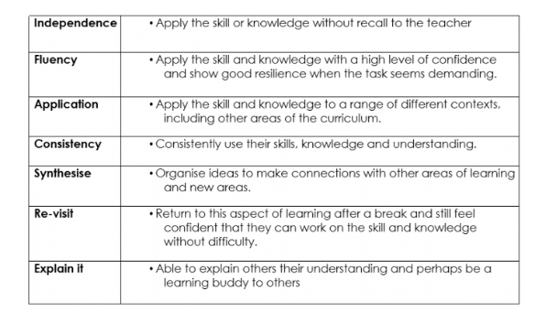
Writing:
Each year group has an outline of objectives for writing from the Teacher Assessment Framework. The year 2 and year 6 document is published by the Standard and Testing Agency. Years 1, 3, 4 and 5 use the local authority TAF sheets for assessment. Each sheet has the objectives for working towards, expected and greater depth standards. These objectives are not ‘best fit’ and pupils have to demonstrate their ability to meet the standards across a range of texts, writing for different purposes and audiences.

Literacy Book Overview
Year 3
Autumn Term |  | Spring Term |  | Summer Term
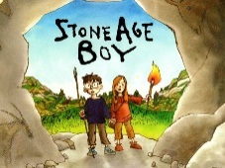  Stone Age Boy by Satoshi Kitamura  The Day the Crayons Quit by Oliver Jeffers | Ice Palace  Robert Swindells  Tin Forest  Helen Ward | Alice in Wonderland  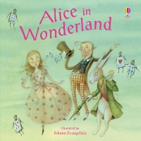 | 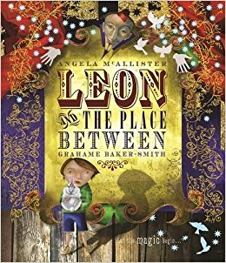  Leon and The Place Between by Grahame Barker Smith  Gorilla by Anthony Browne | 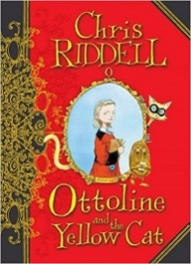  Ottoline and the Yellow Cat by Chris Riddle | 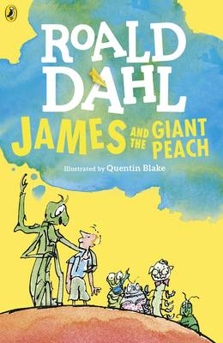  James and the Giant Peach by Roald Dahl

Year 4
Autumn Term |  | Spring Term |  | Summer Term
Zoo by Anthony Browne  Hansel and Gretel by Neil Gaiman  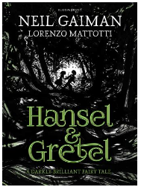 | 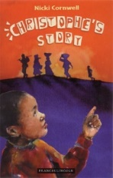  Christophe’s Story by Nicki Cornwell  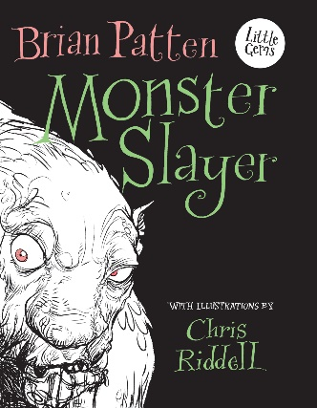  Monster Slayer by Brian Patten | The Iron Man by Ted Hughes  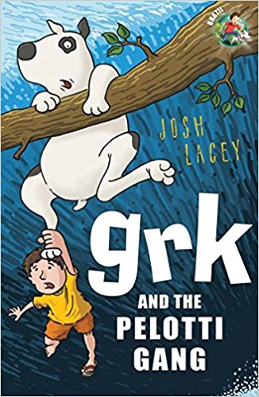  Grk and the Pelotti Gang by Josh Lacey | 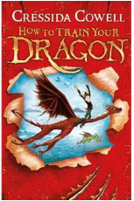  How to Train Your Dragon by Cressida Cowell | 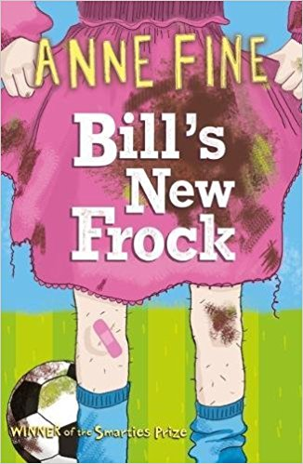  Bill’s New Frock by Anne Fine  The Firework Maker’s Daughter by Philip Pullman | Varjak Paw by SF Said

Year 5
Autumn Term |  | Spring Term |  | Summer Term
The Day of Ahmed’s Secret by Florence Parry Heide and Judith Heide Gilliland  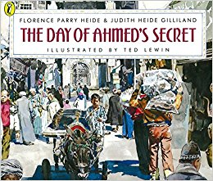  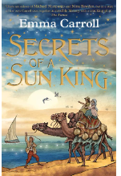  Secrets of a Sun King by Emma Carroll | Kaspar Prince of Cats by Michael Morpurgo  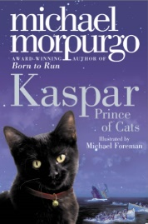 | Sir Gawain and the Loathly Lady by Selina Hastings  The Highwayman Narrative Poem by Alfred Noyes | Journey to Jo’burg by Beverley Naidoo | Holes by Louis Sachar  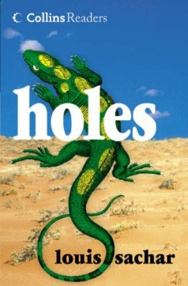 | Clockwork by Philip Pullman  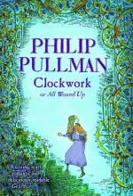

Year 6
Autumn Term |  | Spring Term |  | Summer Term
The Lion, The Witch and The Wardrobe – C.S. Lewis | 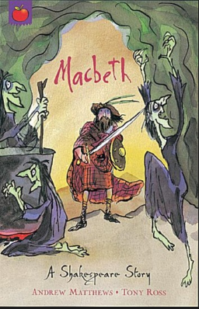  Macbeth – A Shakespeare Story by Andrew Matthews  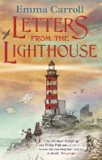  Letters from the Lighthouse by Emma Carroll. | Kensuke’s Kingdom – Michael Morpurgo  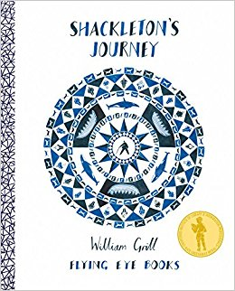  Shackleton’s Journey – William Gil | Skellig – David Almond and William Blake poetry  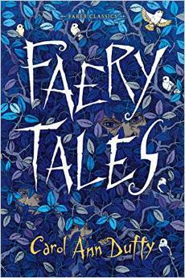  Faery Tales by Carol-Ann Duffy | The Tales of Harris Burdick – Chris Van Allsberg  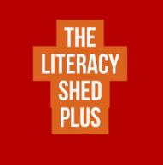  Literacy Shed suspense stories | 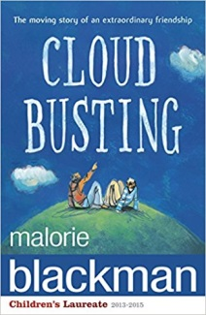  Cloud Busting – Malorie Blackman

