**St. Andrew’s CE (VA) Infant School and St. Andrew’s CE (VA)**

**Junior School**

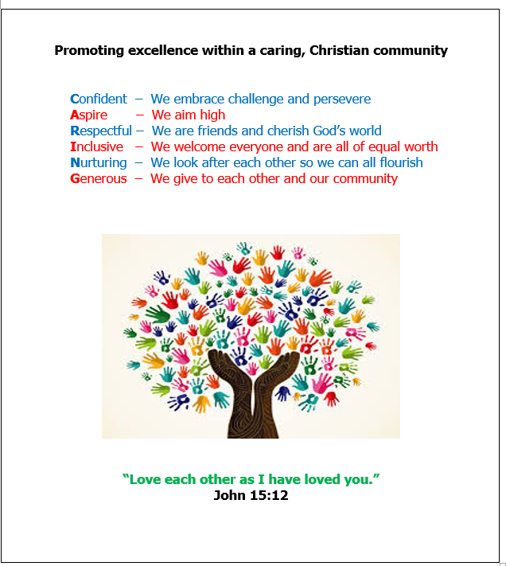**Behaviour Curriculum**



At St Andrew’s, our Christian vision and ethos underpins everything we do. We strive to ensure that the children in our care are nurtured to ensure the development of the whole child. Academic, spiritual, emotional and personal development are all equally valued and supported through our CARING vision.

**“Love one another as I have loved you.” John 15:12**

Our St Andrew’s Behaviour Curriculum is designed to teach children the behaviours and habits we expect to see in school. This teaching runs alongside our School Behaviour Policy. As outlined in the EEF document ‘Improving Behaviour in Schools’, there needs to be a shift of focus from managing behaviour toward teaching a child the correct learning behaviours. *“The successful management of behaviour relies on far more than a set of strategies to draw upon when pupils misbehave.”* Ellis and Tod (2018).

All staff at St Andrew’s have high expectations of behaviour, so these expectations are taught, modelled and promoted through our CARING vision. If children and staff ‘live our vision’, then all pupils can show the required learning behaviours in school. We embed these behaviours though clear communication of what we want to see and frequent positive reinforcement. In addition to our vision, the school has a Christian Value as a focus each half term. These values are another way of teaching morals and reinforcing our Christian ethos.

The Behaviour Curriculum and the Behaviour Policy were developed after careful consideration of the following:

* DfE Behaviour in Schools guide (February 2024)
* EEF Improving Behaviour in Schools Guidance Report
* When the Adult Changes, Everything Changes by Paul Dix
* Zones of Regulation Training delivered by Anna Robinson

The aim of our Behaviour Curriculum is to create positive, motivated children who enjoy their learning in school, and who can grow to be polite, respectful and caring adults.

**Teaching learning behaviours**

Behaviour is taught explicitly during the first few weeks of Autumn Term. The approach to teaching behaviour is the same as all other lessons: the teacher will explain, model and allow time for the children to apply their learning independently. Once clear routines and expectations have been established, they will be revisited often.

All expectations of behaviour and conduct are underpinned by three key expectations known as the ‘Three Golden Rules’:

* **Be Kind**
* **Be Caring**
* **Be Respectful**

Children will be taught what these expectations mean, and the teacher will use positive reinforcement to support this learning.

|  |  |  |
| --- | --- | --- |
| What is being **KIND**? | What is being **CARING**? | What is being **RESPECTFUL**? |
| Being kind is all about being kind to ourselves, other children and adults.  We show this by:   * Using our hands and feet kindly so we don’t hurt others * Using kind words * Offering to help others * Speaking to an adult when you feel unsafe or are worried about another child * Moving quietly and sensibly in the cloakrooms | Being caring is all about caring about our learning, our work and our conduct in school.  We show this by:   * Trying our best in our work * Listening well in class and giving the teacher our full attention * Sitting properly, ready to learn * Sitting silently in collective worship * Lining up smartly and quietly | Being respectful is all about treating adults, children and our school with respect.  We show this by:   * Having good manners and always saying please and thank you * Holding the door open for adults or stepping aside * Greeting others with a smile and good morning/afternoon * Walking sensibly around school * Looking after our equipment including our library and playtime equipment |

**Inclusion**

At St Andrew’s we recognise that some children require adaptations to lessons in order to be able to be successful, and behaviour is no exception. When applying the Behaviour Policy, consideration will be given to a child’s age and SEND needs. All children will be taught the Behaviour Curriculum, but some children may need more support to succeed.

**Curriculum Content**

The class teacher is responsible for teaching the Behaviour Curriculum content at the start of each school year. It is then every staff member’s responsibility to revisit and embed this learning throughout the year through high expectations and positive reinforcement. Each area has a child-friendly title (underlined) to use as a reminder.

**Classroom Expectations: Being ready to learn**

* We sit/stand up straight
* We keep our chair and feet on the floor
* We look at the person talking
* We remain silent
* We indicate if we want to talk – we don’t interrupt
* We keep our hands still and empty of equipment
* We line up quickly and quietly in and orderly manner
* We try our best in all lessons

**Collective worship: Gathering respectfully for worship**

* We walk in to and out of the hall in single file
* We enter without talking and singing along to the song
* We sit down silently and keep our hands to ourselves
* We face forward and look at the person talking
* We remain silent unless answering a question or singing
* We raise our hands to share a response or answer a question
* We join in when singing a song

**Playtimes and lunchtimes: Playing kindly and respectfully**

* We line up quickly and quietly in and orderly manner
* We play kindly and gently so we don’t hurt one another
* We are kind and compassionate when playing games and sharing equipment
* We take care of our school equipment
* We take care of our own belongings, such as coats and jumpers

**In the dining room: Eating respectfully**

* We use quiet voices, only talking to those around us
* We use knives and forks to eat our hot food
* We walk around carefully so we don’t drop or knock anything over
* We clean up after ourselves, including food dropped on the table or floor
* We leave the table tidy as we leave and tuck our chairs under
* We put all of our cutlery and our plates away properly

**Around school: Respecting our school**

* We say ‘good morning/afternoon’ to greet adults we pass
* We hold the door open or stand aside for adults
* We walk around school smartly with our shirts tucked in
* We treat school resources and equipment with care and respect
* We use our manners when asking for or receiving something
* We speak to an adult if we feel unsafe or concerned about someone else
* We are quick, careful and considerate of others in the cloakroom
* We take pride in our school and keep it neat and tidy

**On school trips: Representing our school**

* We listen carefully to adult instructions
* We walk around carefully and show consideration to members of the public
* We talk quietly so we do not disturb others
* We are polite and use our manners when speaking to people we meet
* We tidy up after ourselves and never leave any rubbish or a mess behind