Pupil premium strategy statement

This statement details our school’s use of pupil premium (and recovery premium for the 2022 to 2023 academic year) funding to help improve the attainment of our disadvantaged pupils.

It outlines our pupil premium strategy, how we intend to spend the funding in this academic year and the effect that last year’s spending of pupil premium had within our school.
Updates for 2023/24 academic year in red

School overview
Detail | Data
School name | St Andrew’s CE (VA) Junior School
Number of pupils in school | 224
Proportion (%) of pupil premium eligible pupils | 32%
Academic year/years that our current pupil premium strategy plan covers (3 year plans are recommended) | 2022-2025
Date this statement was published | November 2022
Date on which it will be reviewed | October 2024
Statement authorised by
Pupil premium lead | Louisa Riley
Governor / Trustee lead | Graham Lawley
Funding overview
Detail | Amount
Pupil premium funding allocation this academic year | 99,950
Recovery premium funding allocation this academic year | £0
Pupil premium funding carried forward from previous years (enter £0 if not applicable) | £0
Total budget for this academic year  If your school is an academy in a trust that pools this funding, state the amount available to your school this academic year | £99,950

Part A: Pupil premium strategy plan

Statement of intent
At St Andrew’s Junior School, we have high expectations for all pupils in our school. We believe that every child, irrespective of their backgrounds, can make good progress and fulfil their individual potential. The focus of our pupil premium strategy is to support disadvantaged pupils to achieve that goal and ensure that there is progress and challenge for those who are already high attainers.
Through quality first teaching, an individualised learning approach and effective engagement with parents, we believe that all children can achieve, both academically and socially. Leaders ensure that all children receive teaching which is at least good in every lesson and that disadvantaged children receive frequent intervention and daily support to close any gaps in their learning. Our aim is that disadvantaged children make as much progress as non-pupil premium children, both at our school and nationally.
In addition to our academic focus, we are committed to meeting our pupils’ pastoral and social needs in a nurturing environment. We recognise that pupil premium children may not be exposed to rich learning experiences out of school, so we provide ‘memorable experiences’ through the curriculum to address this. All children, including those who are not disadvantaged, benefit from this approach. Additional help with funding for trips and experiences for disadvantaged children ensure that no one misses out on this crucial part of learning.
Our wider school strategy has tutoring and catch up sessions in place for education recovery from the pandemic. Pupil premium children have priority access to in school tutoring and catch up.
Using Sonar, leaders will ensure that the progress of pupil premium children is robustly monitored and that any gaps or challenges are addressed quickly. Our response will be based on assessment, not assumptions about the impact of disadvantage.

Challenges

This details the key challenges to achievement that we have identified among our disadvantaged pupils.
Challenge number | Detail of challenge
1 | Attendance data shows that the attendance of our Pupil Premium children is lower than that of Non-Pupil Premium children.
2 | Assessment data, observations, books and discussions show that there is a gap in attainment between Pupil Premium children and Non-Pupil Premium children in writing.
3 | In school observations, pupil planners and reading data shows a lack of engagement in reading for Pupil Premium children.
4 | Analysis of our speech and language referral register shows that 70% of pupils with a speech or language problem are Pupil Premium children.
5 | Our SEND register shows that a high proportion of our Pupil Premium children have an additional need; 60% are on the SEND register and 55% have SEMH needs.

Intended outcomes
This explains the outcomes we are aiming for by the end of our current strategy plan, and how we will measure whether they have been achieved.
Intended outcome | Success criteria
- To narrow the gap in attendance for our PP children so that it becomes broadly in line with the attendance of our non-PP children. | Attendance of PP children will improve so that the gap between PP children and non-PP children narrows.
- To reduce the attainment gap of PP children in writing. | Narrow the gap in attainment between PP and non-PP children in writing by enabling more PP children to reach ARE or above.  Use internal tracking (Target Tracker) to monitor progress of PP children to ensure it is equal to or greater than their non-PP peers.
- To foster a love of reading in order to narrow the attainment gap in reading. | Narrow the gap in attainment between PP and non-PP children in reading.  Increase the amount of reading PP children do both in school and at home.  Use pupil voice to measure pupil’s opinions of reading.  Star Reader data to monitor reading ages and gaps between reading age and real age.
- Children have access to additional support for speech and language needs | Lingo assessments used to identify children with speech and language difficulties.  PP children prioritised for SALT referrals.
- Children have access to additional support for their additional needs | PPPs/One page plans used to identify additional needs and put strategies in place to help with these needs  Lunch time groups used to support behavioural needs so PP children will reduce behaviour points

Activity in this academic year
This details how we intend to spend our pupil premium (and recovery premium funding) this academic year to address the challenges listed above.

Teaching (for example, CPD, recruitment and retention)
Budgeted cost: £ 43,130
Activity | Evidence that supports this approach | Challenge number(s) addressed
Quality first teaching for all pupils  - Ongoing CPD for all teachers in English and maths from English and maths lead  - Writing is a priority on the school development plan  - Pupil progress meetings track progress of PP pupils and appropriate, timely interventions are put in place  - Pupil Premium outcomes and strategies monitored by Assistant Head | - EEF Guide to Pupil Premium shows that teaching is the top priority, including CPD.  - Sutton Trust says that quality first teaching has a direct impact on student outcomes. | 2, 3, 5
Teaching Assistants and class teacher to target PP children for regular reading in class.  - All classes have a reading folder to track reading  - TA for every class in a morning  - Bottom 20% and PP are a focus  - Folders are monitored by SLT to ensure they are being used and to identify the need for any CPD | - In school data/monitoring shows that PP pupils are the ones most likely to not read at home.  - Teaching ‘Reading comprehension strategies’ is shown as high impact, very low cost based on EEF research (+6 months) EEF Toolkit | 2, 3, 5
Teachers/TAs to be trained to use the Ruth Miskin Read Write Inc phonics scheme  - Purchase a range of phonically decodable books based on or just below the child’s current phonic level  - Lower reader scheme for those below Accelerated Reader reading age of 7 years  Collaboration with the infant school to ensure children are taught and assessed correctly | - As a junior school, we are currently increasing the amount of trained, skilled phonics teachers that we have  - The DfE says schools which have a consistent approach to phonics achieve good results DfE Reading Framework 2021  - EEF research shows phonics teaching is high impact, low cost based on extensive evidence (+5 months) EEF Toolkit | 2, 3, 5
CPD for teachers on metacognition strategies  - Quick 6 used in all foundation subjects to revisit sticky knowledge  - Types of thinking strategies taught and displayed using animal logos for prompts | - Teaching children to understand their learning style and use approaches that work will help them take ownership of their learning. (EEF Toolkit - high impact, very low cost based on extensive research +7 months) | 2, 3, 5

Targeted academic support (for example, tutoring, one-to-one support structured interventions)
Budgeted cost: £27,503 (+19,000 additional for the academic mentor)
Activity | Evidence that supports this approach | Challenge number(s) addressed
SHINE interventions | - SHINE interventions in reading and maths are used to give individualised targets and support.  - Allows adults to give specific feedback (EEF Toolkit +6 months)  Individualised instruction helps children understand their strengths and weaknesses (EEF Toolkit +4 months) | 2, 3, 5
Academic Mentor | - School based mentor to provide targeted support to small groups and individuals in English and maths. (EEF Toolkit +4 months ) | 2,3, 5
Catch up tutoring provided in maths, reading and writing  - Tuition prioritises PP children | - External provider of small group catch up in English and maths (EEF Toolkit +4 months ) | 2, 3, 5
Same day intervention  - All classes have a TA | - TAs provide same day intervention to allow children to keep up, not catch up with their peers.  - Children feel more confident knowing they can have extra teaching and support if necessary.  EEF Toolkit shows TA interventions can increase attainment by 4 months and small group tuition by 4 months. | 2, 3, 5

Wider strategies (for example, related to attendance, behaviour, wellbeing)
Budgeted cost: £ 28,255
Activity | Evidence that supports this approach | Challenge number(s) addressed
Food and resources provided in and out of school for those in need  - Funded breakfast club and after-school club places  - Food parcels provided for PP families in need  - Free uniform provided if required  - ‘Jigsaw Juice’ club provided for PP children at playtimes  - Milk provided at lunchtimes  - Fruit snack provided daily for morning playtime/start of school for years 3 & 6 (vulnerable year group). | - Breakfast club places ensure children are at school on time.  - Having a breakfast allows children to be ready to learn when they reach the classroom (Maslow’s Hierachy of Needs) | 1, 5
Full and part time Learning Mentors in school  - All PP children have access to a Learning Mentor (LM)  - LMs carry out home visits for pupils not in school  - LMs are out in the playground each morning to meet parents or children with any concerns  - They are a point of contact for vulnerable families and create relationships with them to encourage interaction  - SEMH interventions run by LMs including Calm Club and Jigsaw Juice  - Safe space provided for children including LM office and calm room | - PP children are more likely to be identified as needing additional support for behaviour and emotional difficulties (DfE Mental Health and Wellbeing Provisions in Schools)  - EEF shows parental engagement makes a difference in attainment (EEF Toolkit +4 months) | 5, 1,
Homework club  - PP children have priority for places  - Teacher available for support | - Teacher led homework club during lunchtime each week to target PP with limited parental support at home (EEF Toolkit homework +5 months) | 2,3, 5
Library revamp to make it an inviting place to read. Daily library club at lunchtimes. Wide variety of books, newspapers, comics and magazines available to foster a love of reading.  - PP children to have priority access to library club  - Adult available to read to or with  - The library area is being revamped to include soft furnishings to encourage children to visit more  - A range of new books are being ordered to add to the dyslexia friendly section and the high/low reader section | - EEF states that evidence for a balanced approach to reading is extensive.  - The National Literacy Trust (NLT) states that primary school libraries are in important part of the learning environment for pupils  - The NLT also state that primary school libraries are likely to have an important role to play in the academic recovery from COVID-19.  - The Scottish Library Information Council (SLIC) states that libraries promote positive emotional responses in individuals, reduce the attainment gap and can lead to higher scores in standardised tests in reading, writing, maths, history and science. | 3, 2, 5
Fostering a love of reading  - Parent information meetings at school to help teach strategies to improve and encourage reading  - Planners used throughout school to promote home-school engagement with focus on PP children to encourage more interaction  - School to facilitate all children to join the local libarary to encourage engagement with reading outside of school | - EEF – parental engagement + 4 months (EEF Toolkit)  - Reported outcomes of improved parental engagement include improved academic performance. (NFER Teacher Guide: Parental Engagement and Narrowing the Gap in Attainment for Disadvantaged Children 2013) | 3

Total budgeted cost: £ 96,088 (£8212 contingency budget for extra funding if necessary for trips, PRU places or other costs)
Part B: Review of outcomes in the previous academic year

Pupil premium strategy outcomes
This details the impact that our pupil premium activity had on pupils in the 2022 to 2023 academic year.
This review evaluates the second year of a three year plan.
The 2023/24 School Inspection Data Summary Report shows our school to be 6% higher than the national average in terms of disadvantaged pupils.
Outcome 1 – attendance
The IDSR shows that our school has an overall absence of 6.2% for disadvantaged pupils, which is 1.5% below national average for disadvantaged pupil absence. Although it is still slightly higher than the national average for non-disadvantaged pupils, this has decreased by 0.5%. Overall absence has decreased by 1% for disadvantaged pupils. 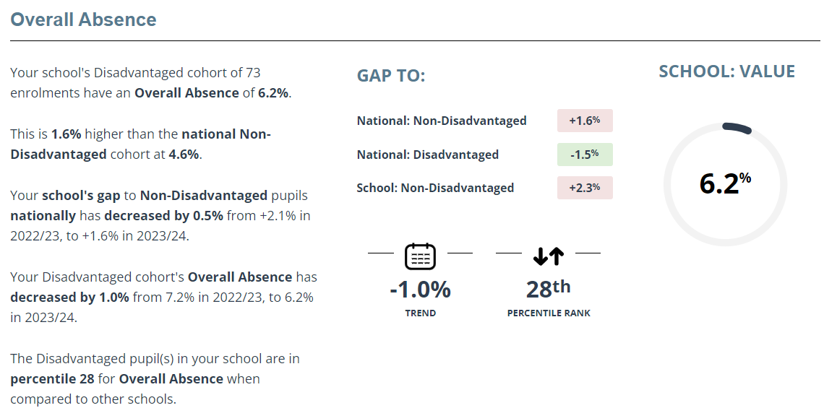
Absence data shows that the gap has not yet closed for PP attendance but it is improving. We are confident that our strategies to improve attendance are working and are beginning to be embedded. However, the complexities of the families and situations involved means that it is not an area that can be quickly ‘fixed’.
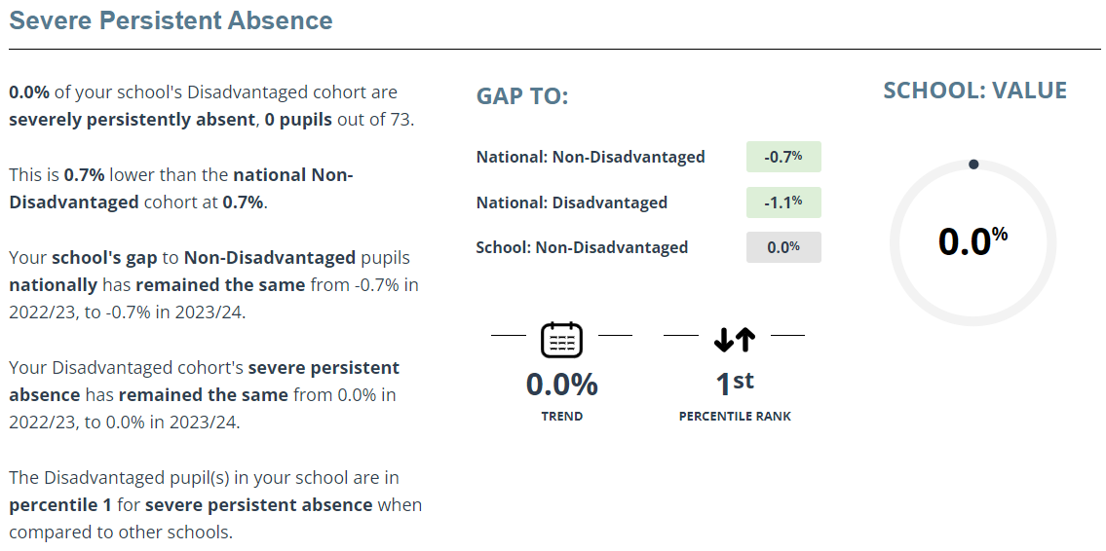
0% of our school’s disadvantaged children are severely persistently absent. This means that our school is in the top 1% of all schools for severe persistent absences.
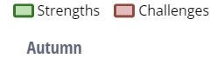
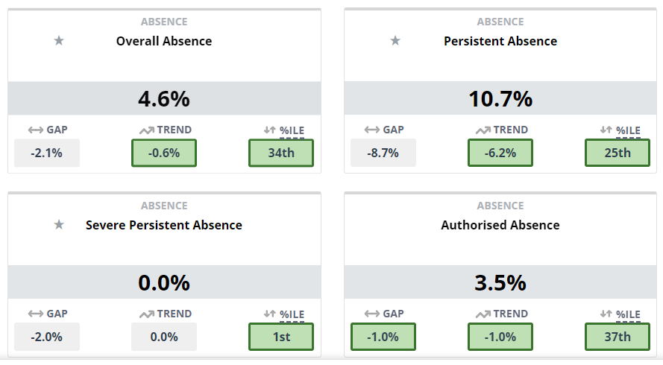
For the Autumn term 2024, absence is showing as a strength in all areas. We remain in the 1st percentile for severe persistent absence.
Actions for 2024/25: Continue to consider individual barriers to attendance for each PP child in order to create a more personalised intervention. Use the EWO to support with persistent cases.
Outcome 2: Reduce attainment gap in writing
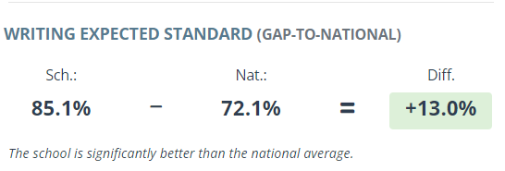
In writing, Perspective Lite shows St Andrew’s is in the 16th percentile for attainment in writing. Writing is seen as a strength of the school, with a significant difference between attainment at school and that nationally.
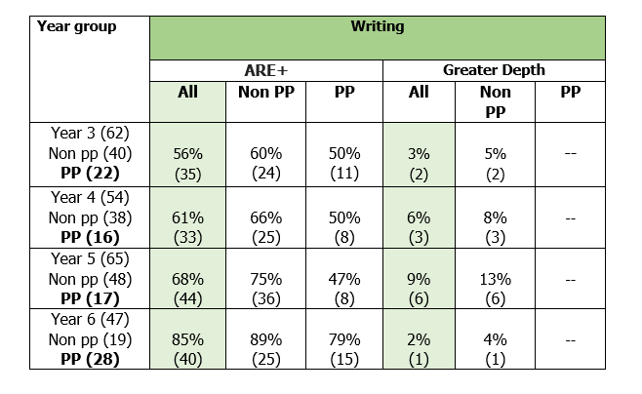
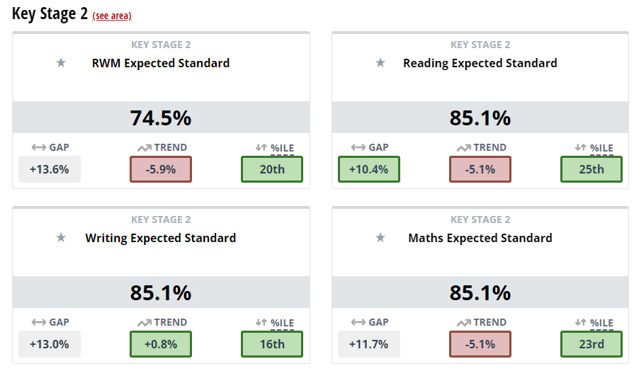
Although our data in writing looks good compared to national trends, internal results show that there is still a gap between writing attainment for PP and no PP children.
July 2024 results  Number of pupils at ARE | Reading | Writing | Maths
Whole School | 78% | 67% | 74%
Pupil Premium | 63% | 51% | 58%
Non Pupil Premium | 88% | 76% | 77%
Gap | 25% | 25% | 19%
Reading attainment links closely to writing outcomes, so both reading and writing are being prioritised for all, with a close focus on PP children. We are expecting these gaps to close as they move through school.
Phonics interventions are working well and children are moving through the scheme quickly. Most children in year 3 no longer needed any intervention after Spring Term. It will now take time to transfer this learning from intervention into class work.
Actions for 2024/25: Continue to monitor the barriers to learning that each PP child has. The individual barriers are to be broken down further into smaller steps e.g transcriptional skills, vocabulary knowledge, stamina etc to further improve and target the interventions we have. The PP lead will attend pupil progress meetings to focus on strategies and outcomes for PP children.
Outcome 3: Foster a love of reading to narrow the attainment gap
Data from July 2024 shows that there is still a gap between PP children and non-PP for attainment in reading. However, this gap is narrowing by the time children reach year 6. Reading attainment overall is still strong: 85% of children reached the expected standard or higher compared to the national figure of 75%.
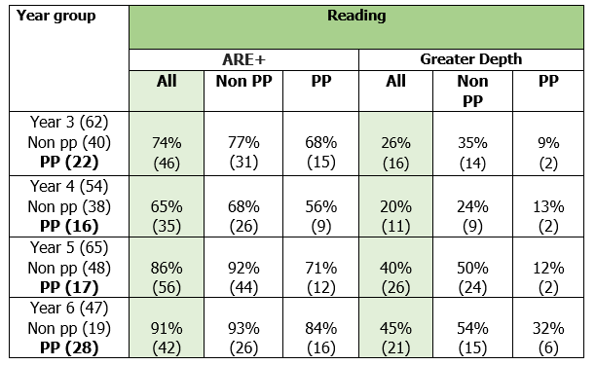.
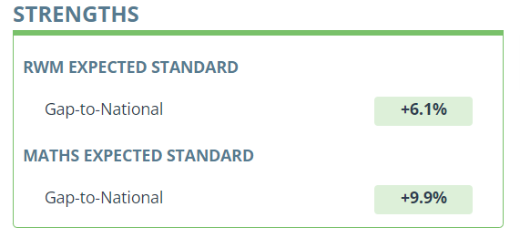
Our RWM combined scores for disadvantaged children re 6.1% above that of the national disadvantaged scores.
Actions for 2024/2025: Continue to prioritise reading for PP children in every year group. Use SHINE interventions where necessary to improve reading comprehension and ‘Fixing Fluency’ techniques as an intervention for fluency.
Outcome 4: Access to additional support for speech and language needs
PP children continue to be prioritised for referral to the SALT and LINGO. Low oracy skills have been identified as a barrier for a high proportion of PP children who are not working at the expected standard in writing. Funding from the diocese has ensured that LINGO interventions can continue until at least July 2025.
CPD has been given to all teachers on how to develop oracy in the classroom and a speaking and listening/oracy plan has been made for each year group based on Voice 21 strategies to help improve children’s oracy skills. PP and SEND children will be the main focus for these strategies.
Actions for 2023/24: Continue to monitor data for both PP and non-PP children to assess the impact.
Outcome 5: Access to additional support for additional needs
All pupils with additional needs now have a one page plan which are reviewed regularly and updated if necessary. Current strategies are working, evidenced by reduced number of behaviour incidents in school. Pupil voice also shows that children feel safe in school.
Extra support is offered to parents of disadvantaged pupils if requested, this is provided by our learning mentor team. Support can include financial help, food parcels and Christmas gifts.
Funded breakfast club continues and an additional nurture breakfast group has been set up to allow a calm entry into school (after the whole-school breakfast club). This provides food and some time for a Zones of Regulation meeting with vulnerable children.
SLT meet weekly to review the needs of PP and vulnerable children and adapt strategies when required to ensure all needs are being met.
Actions for 2024/25: Evaluate the types of lunchtime groups on offer and check which are being used. Pupil voice questionnaires to see which clubs are making a difference, which are not and if there are any other clubs or offerings that they would like to see.

Externally provided programmes
Please include the names of any non-DfE programmes that you purchased in the previous academic year. This will help the Department for Education identify which ones are popular in England
Programme | Provider
Catch up tutoring in maths | Go Educate

